Source: Ohio Historical Society – David Barker
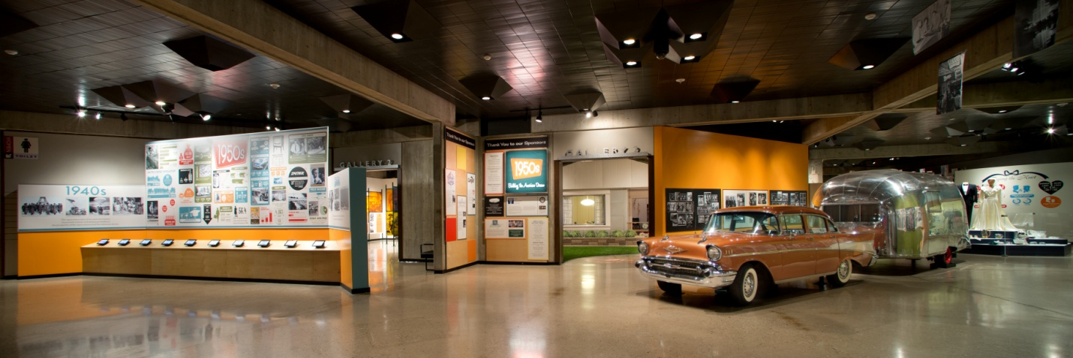
“Hello honey, I’m home!” calls out the quintessential 50’s father to his wife across the almost completely steel Lustron house situated in the Ohio Historical Society’s latest all immersive exhibition. Previously taken from an exhibit named Home Delivery: Fabricating the Modern Delivery located at Museum of Modern Art in New York, this Lustron Serial #549 was pieced together at its original birthplace with the oversight of Cameron Wood, the history curator at the OHS, to house OHS’s first successful all immersive experience. But the infamous pre-fabricated, porcelain-enamel painted house is only a small piece to the larger experience. Engaging multiple layers of sensory stimulations, William Mahon, the Department Head for Exhibit Design and Fabrication pairs with Wood to reach out and invigorate your scents, sights, sounds and memory.
“We wanted to have as much as of a sensory experience as possible for visitors coming in. The idea of smells and sounds and light changes were important to us,” explains Mahon in a recent interview. Within the 1950’s: Building the American Dream exhibit you’ll find the all steel house, fully furnished with era appropriate appliances and inhabited with actors that reflect the sentiments of the age. Wafting through the house is the smell of freshly baked bread; head outside to talk to the Lustron salesman, watch the child actors play among the astro-turf and you’ll be greeted with a pleasant floral garden scent.
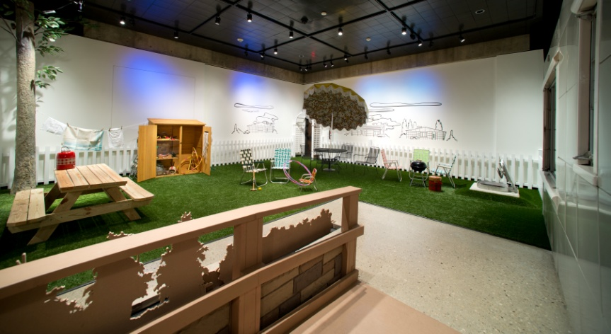
In a growing trend within the museum industry, a large rise of exhibit designers, curators and educators are integrating sensory enhancement technologies into their museums to create a more engaging experience for their visitors. Mahon discusses his intention with building his own version of these multi-layered realities: “My experience in talking with people is that there are so many different learning levels now. Well, we’re aware of them, they’ve always been there but what we’re trying to do is have a whole range of information accessible whenever people are coming into an experience and kind of meeting them there. 15 years ago, a lot of our exhibits [required] a P.H.D. to understand what you’re looking at. Here, we want people to come in and engage and then start their experience and we’re hoping much of their continued experience happens after they’ve left. We want people to engage in history and be excited about it and feel a part of it and I think if we can trigger them with other senses and just personal engagement with the people they’re visiting the exhibit with, then we’re succeeding.”
Source: Ohio Historical Society – David Barker
The Ohio Historical Society has attempted to integrate scents before, about 8 years ago, into a garden exhibit. It was unsuccessful, largely due to technological limitations. Today, however, SensoryCo was able to collaborate with OHS to incorporate an aroma generator that as Mahon puts it, “…have been very seamless; very easy.”
We asked Mahon if he noticed a change in the behavior from his visitors that have visited recently, “We are finding out, at least, we’re seeing people staying in the exhibit a long time and we’ve had really positive responses.”
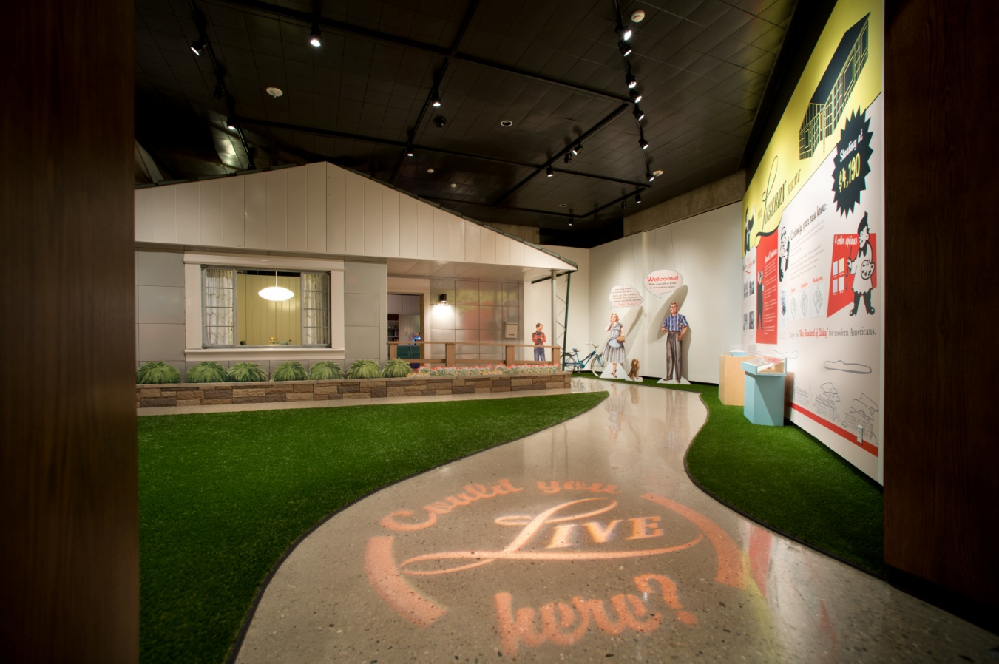
Source; Ohio Historical Society – David Barker
The task of preserving and communicating our cultural and historical history is an enormous task, a tradition that has been taken very seriously across the ages, some might say too seriously. In an effort to inspire people to connect, to engage and to understand their place in this world like never before, innovators like the Ohio Historical Society have pushed through to think outside the Lustron-shaped box. Mahon explains that engaging people’s senses, “[is] an area that we haven’t explored much but it sure triggers people as they’re going into the space right now, I’m observing that. They smell the bread and they’re just like, ‘Oh my god!’ and they start talking about their grandmother. We can’t put that on a text panel, that kind of stuff. I’m excited about it.”
It’s about engagement. It’s about memory. And it’s about connecting. More than anything, it’s about feeling connected to the world around us. The conversation can begin with a 1950’s recreation that incorporates the scents, sights and sounds of the age but it extends to the backyards, the kitchens and the dinner tables of today. As a society, when we’re considering what the true purpose of museums are in a rapidly changing world, let us consider what message we’re trying to deliver: a relation and understanding of where we’ve come from and a focused intent on where we’re going. Bill Mahon and his team have successfully captured this.
What will you do?

